Video killed the radio star The Buggles 1979 tonalité originale : Db BPM : 131

Intro : Dm… C… Dm7… Am… Dm… C… Dm7… G…
Rythme :
BhBh hBh hBhBhBh
C Dm G4 G
A/ -----------12---------10---------8--------/3---2---0---------------12--------10----------8-------10
E/ -------10----------8-----------8----------------------------------10---------8------------8---------10
C/ ----9------------7-----------9--------------1------------------9-----------7-------------9-----------11

C / Dm Gsus4 / G C / Dm Gsus4 / G
I heard you on the wireless back in fifty two Lying awake intent at tuning in on you
C / Dm Gsus4 / G C / Dm Gsus4 / G
If I was young it didn't stop you coming through Oh - a-oh-a

C / Dm Gsus4 / G C / Dm Gsus4 / G
They took the credit for your second symphony Rewritten by machine and new technology
C / Dm Gsus4 / G
And now I understand the problems you can see
C / Dm Gsus4 / G C / Dm / Gsus4 / G
Oh - a-oh-a I met your children Oh - a-oh-a What did you tell them ?

C F C F
Rythme :
BhBh hBhBhBh Bh
C F
Video killed the ra-dio star Video killed the ra-dio star
C / G F G Am
Pictures came and broke your heart Oh, a, a, a, oh

C / Dm Gsus4 / G C / Dm Gsus4 / G
And now we meet in an abandoned studio We hear the playback and it seems so long ago
C / Dm Gsus4 / G
And you remember the jingles used to go
C / Dm Gsus4 / G C / Dm Gsus4 / G
Oh-a oh-a You were the first one Oh-a oh-a You were the last one
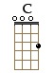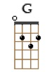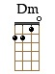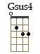
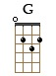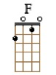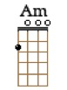
C F C F
Video killed the ra-dio star Video killed the ra-dio star
C / G F C / G F
In my mind and in my car We can't rewind we've gone too far
G Am G Am
Oh, a, a, a, oh Oh, a, a, a, oh

Solo : Dm / G* C* / F* Dm / G* C* / F* Dm / G* E* / Am*
Dm… C… Dm7… [ G↓ Am↓ F↓ Am↓ F↓ - G↓ ] (accords sur 1 temps)
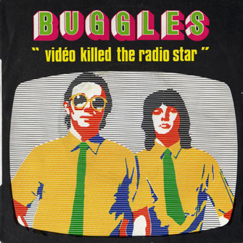
C F C F
Video killed the ra-dio star Video killed the ra-dio star
C / G F C / G F
In my mind and in my car We can't rewind we've gone too far
C / G F C / G F… (F)
Pictures came and broke your heart Put the blame on VCR

C / Dm Gsus4 / G C / Dm Gsus4 / G
you a_____________re… a radio sta__aa___aa__aa___r (x2)
C F C F
Video killed the ra-dio star Video killed the ra-dio star (x4)

Video killed the ra-dio star Video killed the ra-dio star
(x4)
you a___________re a radio sta__________r C↓
G / V2

